# Power Query Instructions

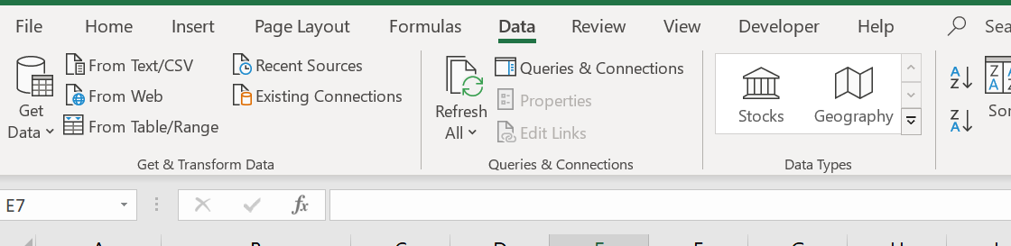This document details the process to run a power query in excel to get the location of all files needed to generate an X-ray pass/fail summary.

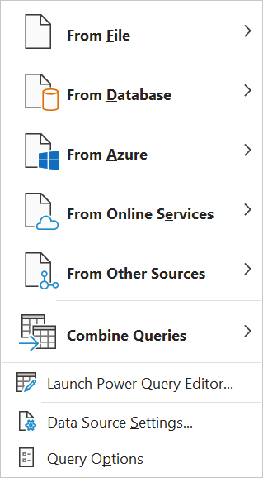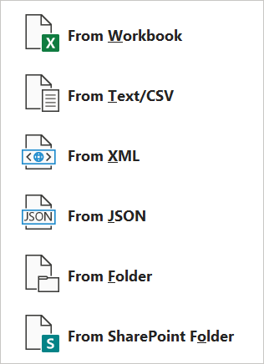

1. Select the “Data” tab in excel, then click “Get Data”, “From File”, “From Folder”

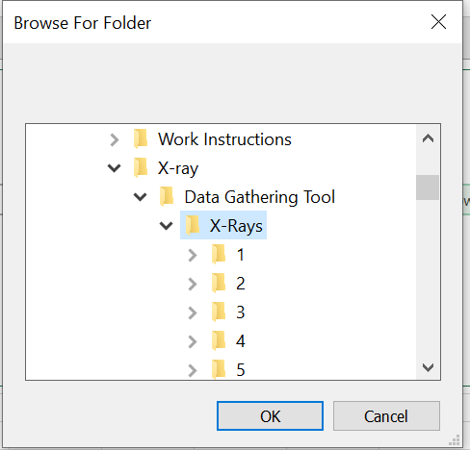

1. Select the folder with the location of the X-rays.

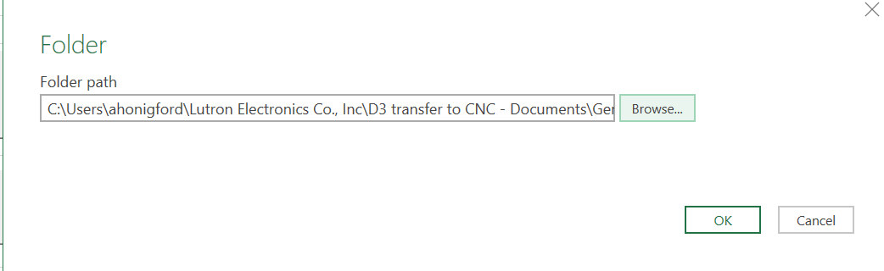

1. Click OK

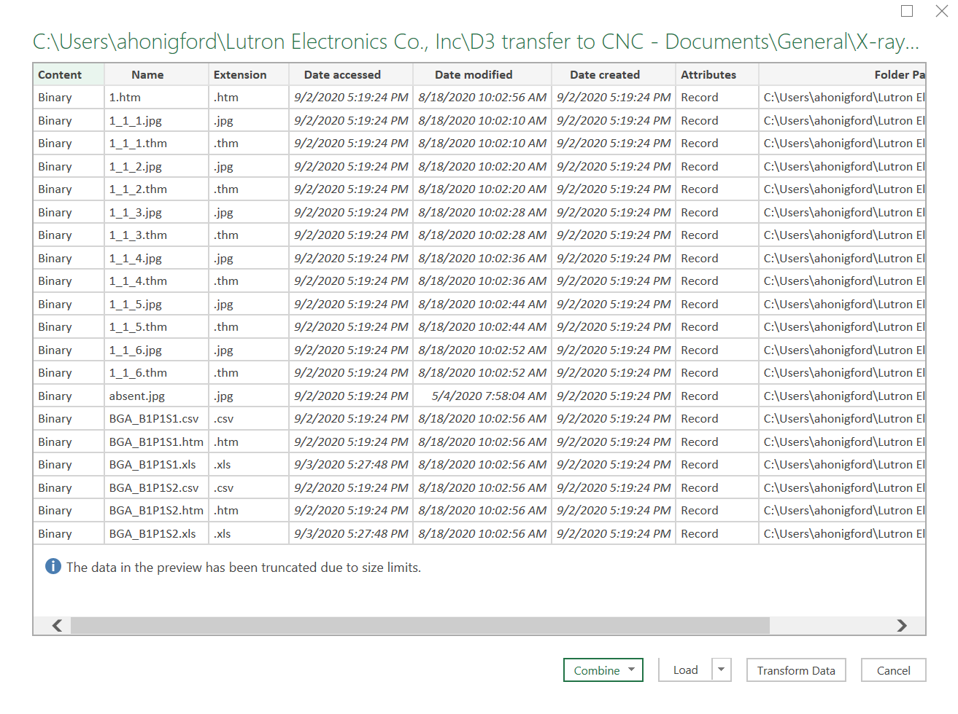

1. Click “Transform Data”

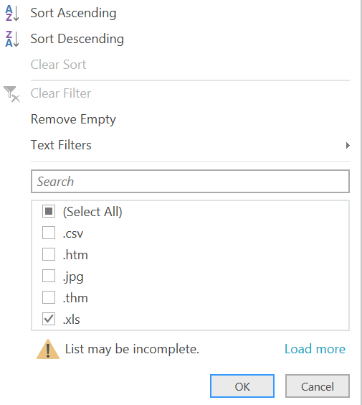

1. Filter by extension and select “.xls”

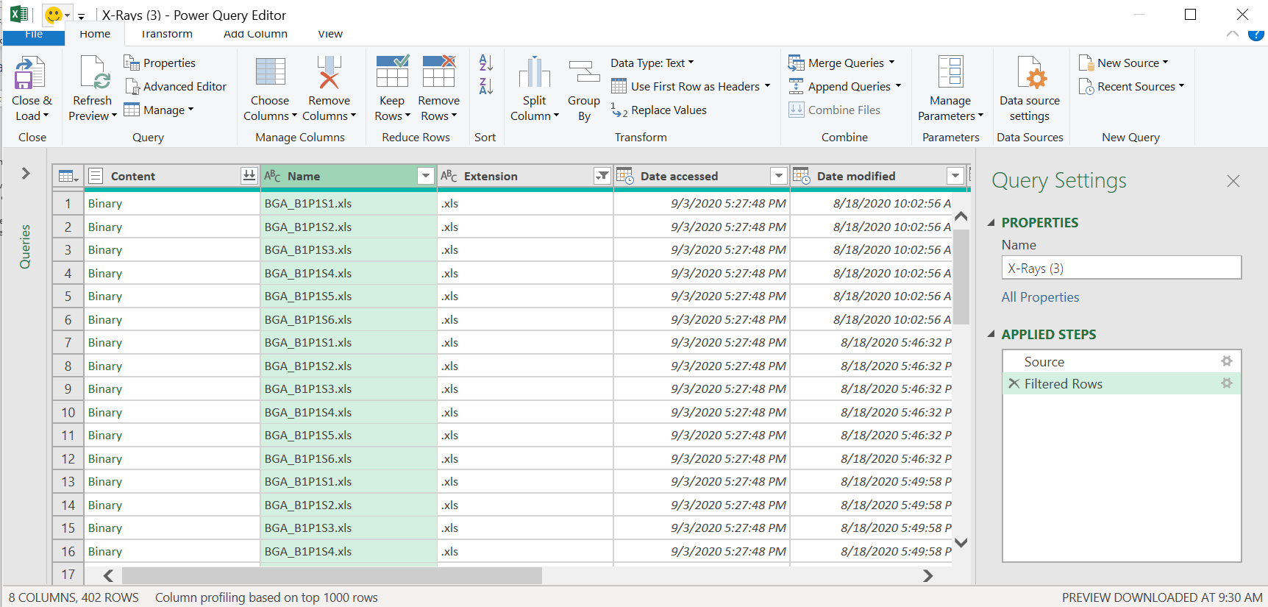

1. Select “Close & Load”